Lab Report No 1



Digital Signal Processing

Submitted By:

Registration No:

Section:

“On my honor , as student of University of Engineering and Technology, I have neither given nor received unauthorized assistance on this academic work”

Student Signature:

Department of Computer Systems Engineering

University of Engineering and Technology Peshawar

**CSE 309L: Communication Systems**

|  |  |  |  |  |
| --- | --- | --- | --- | --- |
| **Demonstration of Concepts** | **Poor (Does not meet expectation (1))**  The student failed to demonstrate a clear understanding of the assignment concepts | **Fair (Meet Expectation (2-3))**  The student demonstrated a clear understanding of some of the assignment concepts | **Good (Exceeds Expectation (4-5)**  The student demonstrated a clear understanding of the assignment concepts | **Score**  **30%** |
| **Accuracy** | The student mis-configured enough signal processing settings that the computer couldn't function properly. | The student configured enough signal processing settings that the computer partially functioned | The student configured the signal processing settings that the computer fully functioned | **30%** |
| **Following Directions** | The student clearly failed to follow the verbal and written instructions to successfully complete the lab | The student failed to follow the some of the verbal and written instructions to successfully complete all requirements of the lab | The student followed the verbal and written instructions to successfully complete requirements of the lab | **20%** |
| **Time Utilization** | The student failed to complete even part of the lab in the allotted amount of time | The student failed to complete the entire lab in the allotted amount of time | The student completed the lab in its entirety in the allotted amount of time | **20%** |

Lab 1: Matlab Training

Visit the following website: <https://www.mathworks.com/learn/tutorials/matlab-onramp.html>

and perform the following tasks and attach the Certificate acquired from MathWorks as part of the lab Report

1. **Course Overview**
   1. Objective: Familiarize yourself with the course.
   2. Remarks along with final snapshot

**Remarks:** I learned about the content of this course.

### Commands

### Objective: Enter commands in MATLAB to perform calculations and create variables.

* 1. Remarks along with final snapshot

**Remarks:** I learned about basic commands of MATLAB in this introductory module.

### Vectors and Matrices

### Objective: Create MATLAB variables that contain multiple elements.

* 1. Remarks along with final snapshot

**Remarks:** In this module, I performed some operations on Vectors and Matrices in MATLAB. I got familiar with Vectors and Matrices manipulation.

### Importing Data

### Objective: Bring data from external files into MATLAB.

* 1. Remarks along with final snapshot

**Remarks:** I learned about importing data from external files in MATLAB in this module.

### Indexing into and Modifying Arrays

### Use indexing to extract and modify rows, columns, and elements of MATLAB arrays.

* 1. Remarks along with final snapshot

### 

### Array Calculations

### Objective: Perform calculations on entire arrays at once.

* 1. Remarks along with final snapshot

### 

### Calling Functions

### Objective: Call functions to obtain multiple outputs

* 1. Remarks along with final snapshot

### 

### Obtaining Help

### Objective: Use the MATLAB documentation to discover information about MATLAB features.

* 1. Remarks along with final snapshot

### 

### Plotting Data

### Visualize variables using MATLAB's plotting functions.

* 1. Remarks along with final snapshot

### 

### *Review Problems*

### Objective: Bring together concepts that you have learned with a project.

* 1. Remarks along with final snapshot

### MATLAB Scripts

### Objective: Write and save your own MATLAB programs

* 1. Remarks along with final snapshot

### Logical Arrays

### Objective: Use logical expressions to help you to extract elements of interest from MATLAB arrays.

* 1. Remarks along with final snapshot

### 

### Programming

### Objective: Write programs that execute code based upon some condition.

* 1. Remarks along with final snapshot

### 

### Final Project

### Objective: Bring together concepts that you have learned with a project.

* 1. Remarks along with final snapshot

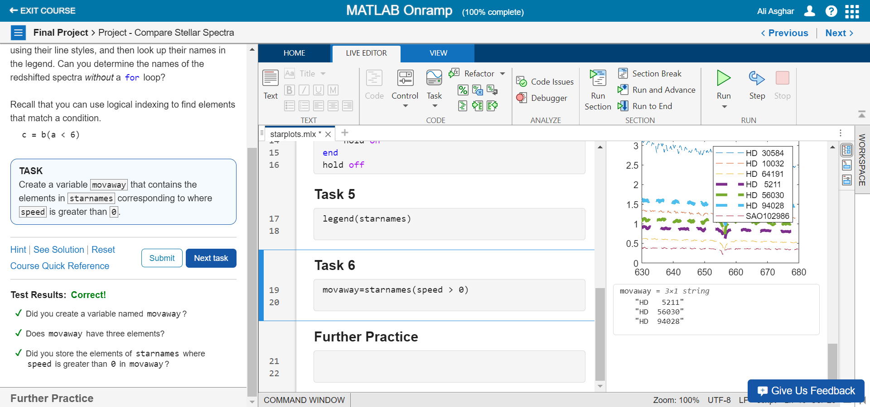

### MathWorks Certificate

### 